**UML Class Diagram + Description**

**Growing Plants**

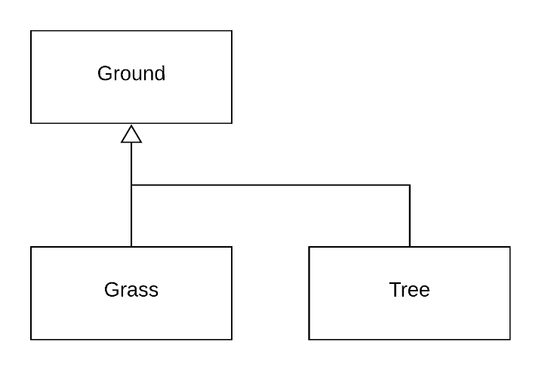

In order to implement the growing of the natural environment we need to add a class that represents grass so that once we go through a tick of in-game time, it uses a random number generator to determine if the dirt at a certain location should be converted into grass. Meanwhile the tree class will have a method that checks the locations directly adjacent to it and will replace it with trees if it fills out certain criteria.

**Hungry Dinosaur**

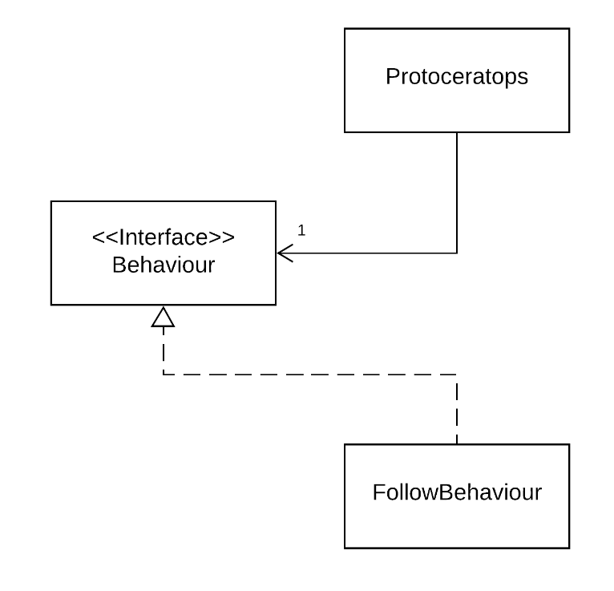

The Protoceratops class will have another attribute added to it that keeps track of its hunger levels. Once that hunger level falls below a certain threshold it calls a behaviour that identifies the closest grass element on the board. Once it has identified this it uses this location as an endpoint for the follow behaviour. From there once it arrives at the location it checks if the location and consumes the grass there, which then increases the hunger level of the specific Protoceratops.

**Buying and Selling**

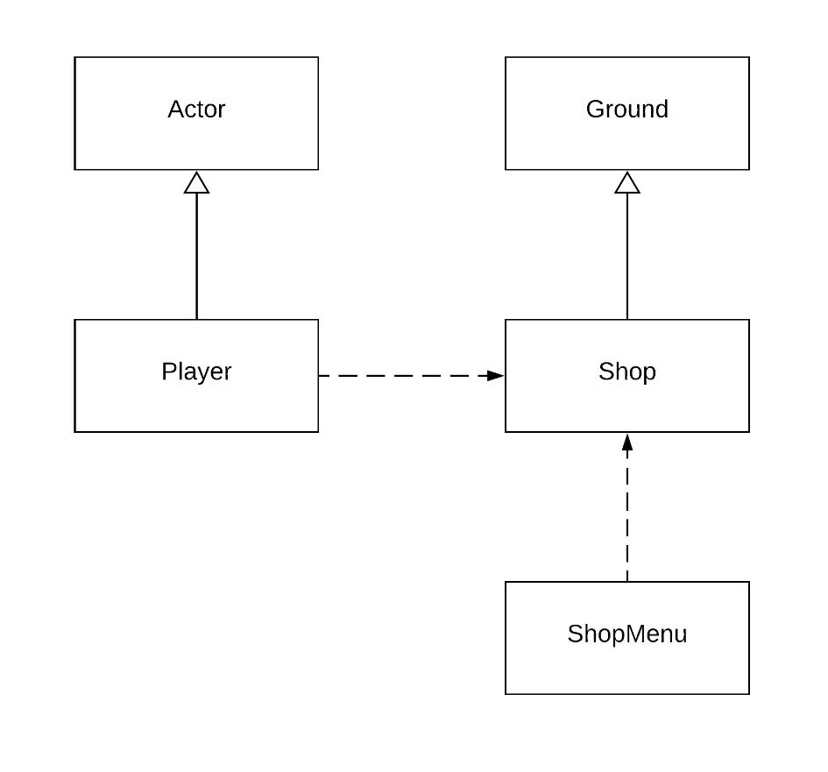

The implementation of the shops works by having a ground element being related to a shop. Which depending on the design of the system could also be the related to the floor class if necessary. We have the shop menu being dependent on the ground which can be identified as a shop tile. From there a player uses the shop tile to either purchase or sell items, these transactions will be handled by the inherent methods present in the actor class.

**Protoceratops and Velociraptors (Velociraptor Eating, Eating, Breeding, Growing)**

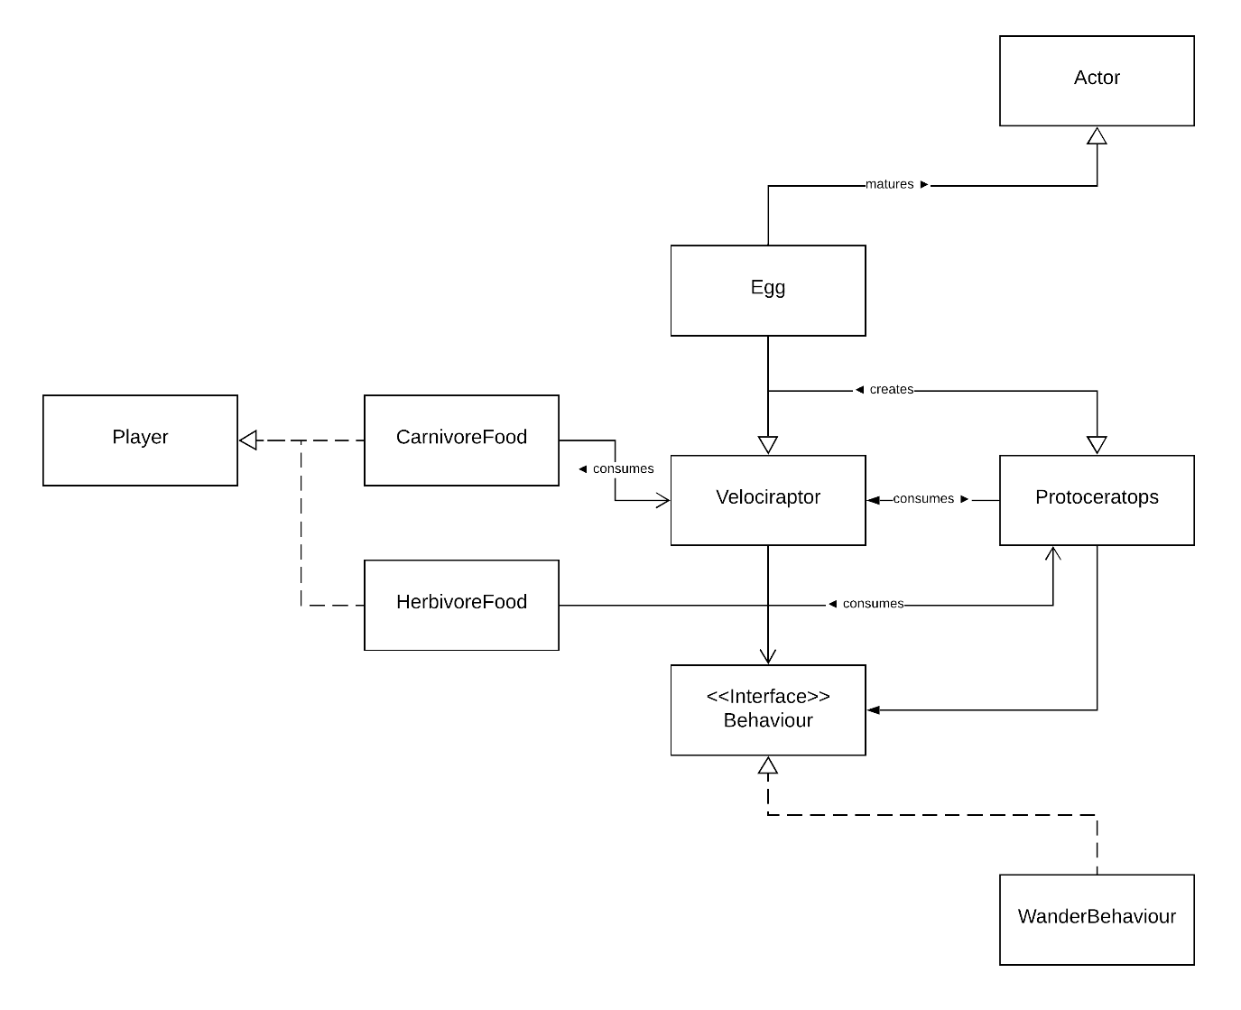

When it comes to the breeding of both the velociraptor and the protoceratops both will have an attribute added to them that determines whether on any given turn they are able to lay an egg. If it passes these criteria it creates an egg object with a variable linking into the type of dinosaur. Once enough turns have passed it will hatch and create an actor based on the original variable determining which type of dinosaur they were. There will also be another attribute added to the velociraptor class and the protoceratops class that will determine their age and will lock them out of specific actions if they are not older then a certain threshold.

When it comes to eating both the protoceratops and the velociraptor can consume food objects placed by the player that can only exist if the player allows it to as these could only exist as a physical object on the map at the discretion of the player. Additionally, velociraptors can also feed on protoceratops as well as dead velociraptors. However, the hunting behaviour would only be called if their food level falls below a certain threshold and would call a behaviour to acquire the closest food source, whether that be by hunting or scavenging. The velociraptor is also given the ability to kill protoceratops, this is done by having the velociraptor have a method that checks adjacent blocks for protoceratops while it is wandering the map.